**Exercise 1: Logging Error Messages and Warning Levels**

**Pom.xml**

<project xmlns="http://maven.apache.org/POM/4.0.0"  
 xmlns:xsi="http://www.w3.org/2001/XMLSchema-instance"  
 xsi:schemaLocation="http://maven.apache.org/POM/4.0.0  
 http://maven.apache.org/xsd/maven-4.0.0.xsd">  
  
 <modelVersion>4.0.0</modelVersion>  
 <groupId>org.example</groupId>  
 <artifactId>JUnit-Mockito-Logging-Demo</artifactId>  
 <version>1.0-SNAPSHOT</version>  
 <properties>  
 <maven.compiler.source>17</maven.compiler.source>  
 <maven.compiler.target>17</maven.compiler.target>  
 <junit.jupiter.version>5.10.2</junit.jupiter.version>  
 <mockito.version>5.12.0</mockito.version>  
 <slf4j.version>2.0.12</slf4j.version>  
 <logback.version>1.5.3</logback.version>  
 </properties>  
 <dependencies>  
 <dependency>  
 <groupId>org.junit.jupiter</groupId>  
 <artifactId>junit-jupiter</artifactId>  
 <version>${junit.jupiter.version}</version>  
 <scope>test</scope>  
 </dependency>  
 <dependency>  
 <groupId>org.mockito</groupId>  
 <artifactId>mockito-core</artifactId>  
 <version>${mockito.version}</version>  
 <scope>test</scope>  
 </dependency>  
 <dependency>  
 <groupId>org.slf4j</groupId>  
 <artifactId>slf4j-api</artifactId>  
 <version>${slf4j.version}</version>  
 </dependency>  
 <dependency>  
 <groupId>ch.qos.logback</groupId>  
 <artifactId>logback-classic</artifactId>  
 <version>1.5.4</version> <!-- Use 1.5.4 or newer -->  
 </dependency>  
 </dependencies>  
 <build>  
 <plugins>  
 <plugin>  
 <groupId>org.apache.maven.plugins</groupId>  
 <artifactId>maven-surefire-plugin</artifactId>  
 <version>3.1.2</version>  
 <configuration>  
 <useModulePath>false</useModulePath>  
 </configuration>  
 </plugin>  
 </plugins>  
 </build>  
</project>

**LoggingExample.java**

package org.example;  
import org.slf4j.Logger;  
import org.slf4j.LoggerFactory;  
public class LoggingExample {  
 private static final Logger *logger*=LoggerFactory.*getLogger*(LoggingExample.class);  
 public static void main(String[] args) {  
 *logger*.error("This is an error message");  
 *logger*.warn("This is a warning message");  
 }  
}

**Output**

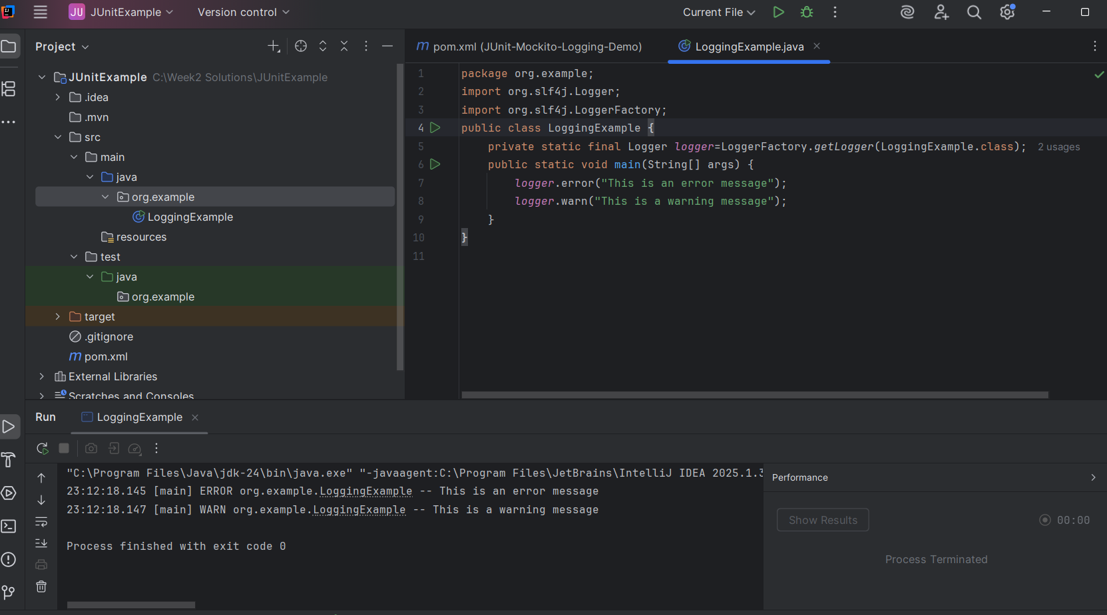

**Exercise 2: Parameterized Logging**

**Pom.xml**

<project xmlns="http://maven.apache.org/POM/4.0.0"  
 xmlns:xsi="http://www.w3.org/2001/XMLSchema-instance"  
 xsi:schemaLocation="http://maven.apache.org/POM/4.0.0  
 http://maven.apache.org/xsd/maven-4.0.0.xsd">  
  
 <modelVersion>4.0.0</modelVersion>  
 <groupId>org.example</groupId>  
 <artifactId>JUnit-Mockito-Logging-Demo</artifactId>  
 <version>1.0-SNAPSHOT</version>  
 <properties>  
 <maven.compiler.source>17</maven.compiler.source>  
 <maven.compiler.target>17</maven.compiler.target>  
 <junit.jupiter.version>5.10.2</junit.jupiter.version>  
 <mockito.version>5.12.0</mockito.version>  
 <slf4j.version>2.0.12</slf4j.version>  
 <logback.version>1.5.3</logback.version>  
 </properties>  
 <dependencies>  
 <dependency>  
 <groupId>org.junit.jupiter</groupId>  
 <artifactId>junit-jupiter</artifactId>  
 <version>${junit.jupiter.version}</version>  
 <scope>test</scope>  
 </dependency>  
 <dependency>  
 <groupId>org.mockito</groupId>  
 <artifactId>mockito-core</artifactId>  
 <version>${mockito.version}</version>  
 <scope>test</scope>  
 </dependency>  
 <dependency>  
 <groupId>org.slf4j</groupId>  
 <artifactId>slf4j-api</artifactId>  
 <version>${slf4j.version}</version>  
 </dependency>  
 <dependency>  
 <groupId>ch.qos.logback</groupId>  
 <artifactId>logback-classic</artifactId>  
 <version>1.5.3</version>  
 </dependency>  
 </dependencies>  
 <build>  
 <plugins>  
 <plugin>  
 <groupId>org.apache.maven.plugins</groupId>  
 <artifactId>maven-surefire-plugin</artifactId>  
 <version>3.1.2</version>  
 <configuration>  
 <useModulePath>false</useModulePath>  
 </configuration>  
 </plugin>  
 </plugins>  
 </build>  
  
</project>

**ParameterizedLoggingExample**

import org.slf4j.Logger;  
import org.slf4j.LoggerFactory;  
public class ParameterizedLoggingExample {  
 private static final Logger *logger*=LoggerFactory.*getLogger*(ParameterizedLoggingExample.class);  
 public static void main(String[] args) {  
 String user="Alice";  
 int attempts=5;  
 *logger*.info("User {} has attempted login {} times",user,attempts);  
 int itemCount=3;  
 double price=29.99;  
 *logger*.debug("You added {} items to your cart. Total cost: ${}", itemCount, itemCount * price);  
 }  
}

**Output**

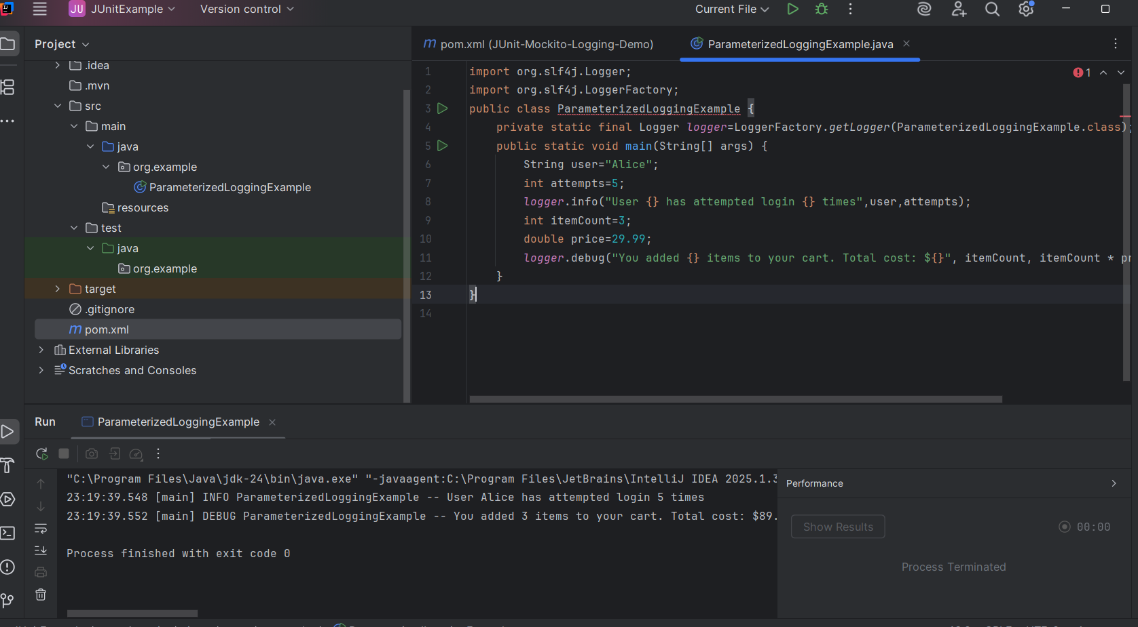

**Exercise 3: Using Different Appenders**

**Pom.xml**

<project xmlns="http://maven.apache.org/POM/4.0.0"  
 xmlns:xsi="http://www.w3.org/2001/XMLSchema-instance"  
 xsi:schemaLocation="http://maven.apache.org/POM/4.0.0  
 http://maven.apache.org/xsd/maven-4.0.0.xsd">  
  
 <modelVersion>4.0.0</modelVersion>  
 <groupId>org.example</groupId>  
 <artifactId>JUnit-Mockito-Logging-Demo</artifactId>  
 <version>1.0-SNAPSHOT</version>  
 <properties>  
 <maven.compiler.source>17</maven.compiler.source>  
 <maven.compiler.target>17</maven.compiler.target>  
 <junit.jupiter.version>5.10.2</junit.jupiter.version>  
 <mockito.version>5.12.0</mockito.version>  
 <slf4j.version>2.0.12</slf4j.version>  
 <logback.version>1.5.3</logback.version>  
 </properties>  
 <dependencies>  
 <dependency>  
 <groupId>org.junit.jupiter</groupId>  
 <artifactId>junit-jupiter</artifactId>  
 <version>${junit.jupiter.version}</version>  
 <scope>test</scope>  
 </dependency>  
 <dependency>  
 <groupId>org.mockito</groupId>  
 <artifactId>mockito-core</artifactId>  
 <version>${mockito.version}</version>  
 <scope>test</scope>  
 </dependency>  
 <dependency>  
 <groupId>org.slf4j</groupId>  
 <artifactId>slf4j-api</artifactId>  
 <version>${slf4j.version}</version>  
 </dependency>  
 <dependency>  
 <groupId>ch.qos.logback</groupId>  
 <artifactId>logback-classic</artifactId>  
 <version>1.5.3</version>  
 </dependency>  
 </dependencies>  
 <build>  
 <plugins>  
 <plugin>  
 <groupId>org.apache.maven.plugins</groupId>  
 <artifactId>maven-surefire-plugin</artifactId>  
 <version>3.1.2</version>  
 <configuration>  
 <useModulePath>false</useModulePath>  
 </configuration>  
 </plugin>  
 </plugins>  
 </build>  
  
</project>

**AppenderExample.java**

package org.example;  
import org.slf4j.Logger;  
import org.slf4j.LoggerFactory;  
public class AppenderExample {  
 private static final Logger *logger* = LoggerFactory.*getLogger*(AppenderExample.class);  
 public static void main(String[] args) {  
 *logger*.debug("This is a debug message");  
 *logger*.info("This is an info message");  
 *logger*.warn("This is a warning message");  
 *logger*.error("This is an error message");  
 }  
}

**Output**

